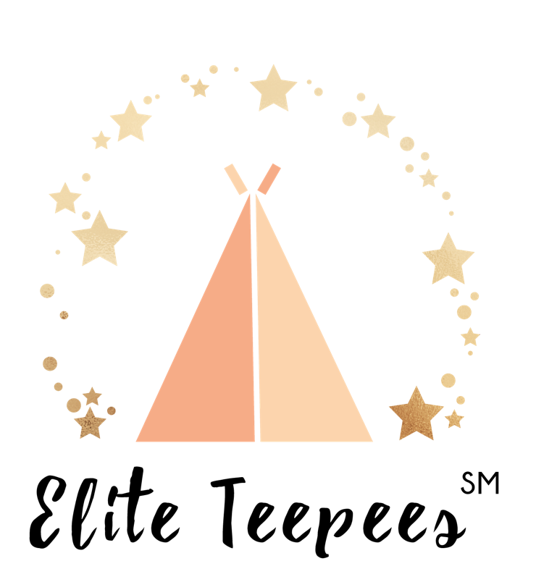
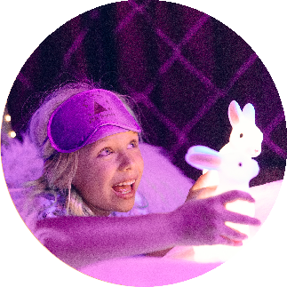

Company Overview

& Licensee Benefits
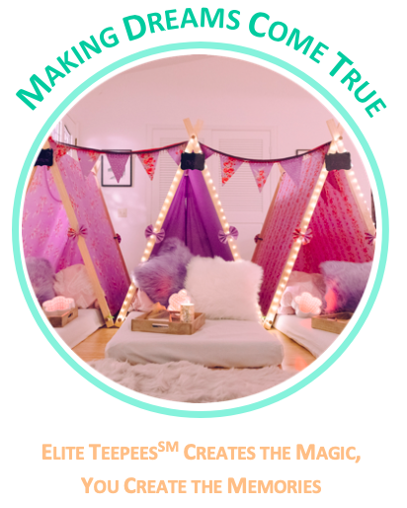

Nikki Kay Founder

Kelli Smith, CEO
Carlsbad, San Diego, California

https://www.instagram.com/eliteteepees/
https://www.facebook.com/eliteteepees/
https://www.eliteteepees.com/
Table of Contents
COMPANY OVERVIEW 1
THE COMPANY AND ITS MANAGEMENT 4
BIRTHDAY PARTY INDUSTRY 5
LICENSEE BENEFITS 7
INCOME POTENTIAL 7
Hot Timing 9
Unique Licensing Opportunity To Own Your Own Business 9
Low Start-Up and Monthly Overhead 9
Flexible Hours and Time 10
Job Satisfaction 10
ELITE TEEPEESSM LICENSING SUMMARY 11

COMPANY OVERVIEW

ELITE TEEPEESSM, established in February 2019 by founder Nikki Kay, is currently the ONLY company in the U.S. offering a licensing opportunity to become part of the $38 billion birthday party industry, with a sleepover experience business. The children’s birthday party industry alone is worth $25 billion. Parents are continuing to seek out higher value and differentiated options for their kids party each and every year.

Elite TeepeesSM are ‘The Sleepover Experts.’ A boutique company specializing in exquisite sleepover experiences. We make dreams come true, by creating magical curated teepee sleepover experiences for kids to bond and create lifelong memories of fun and friendship.
Elite TeepeesSM delivers and styles beautiful handcrafted teepees, then packs everything away the next day, helping to create a magical experience for kids, and a hassle-free experience for parents.
The curated sleepover market has become well established in Australia over the past 3 years and is rapidly expanding in New Zealand, U.K., and now the U.S. According to celebration industry analysts, by 2018 birthday parties had grown, during the past 15 years, into a $38 billion industry in the US. This growth has been sustained during periods of major swings in national and local economies.
If you love seeing pure joy on kids’ faces, have a passion for creativity and a desire to make a difference within your local community, then having your own Elite TeepeesSM business can be an opportunity to earn a great full-time or part-time income.
The founder, decided to sell her business (to emigrate for health reasons) to Kelli Smith in April 2023.

WHY AN ELITE TEEPEESSM BUSINESS?

Growth in the industry internationally has demonstrated that even with a weak economy, parents are still focused on celebrating life’s biggest moments.
A primary reason given for this trend is that spending on children gives parents a sense of accomplishment in providing unique experiences for their kids. So, it is as much about the parents as it is about the kids. This is a powerful dynamic in a business based on feelings and emotion.
This on-trend concept is already booming in Australia, New Zealand, and the U.K.. Although this type and style of luxury sleepover experience in new to the U.S. it is expected to grow rapidly.

WHAT SETS THE ELITE TEEPEESSM BRAND APART?

- Elite TeepeesSM is a Full Service Provider
Elite TeepeesSM delivers & sets up beautifully curated teepees in the comfort of the client’s home, then packs it all away the next day so that they can enjoy a hands-off, exquisite sleepover experience.
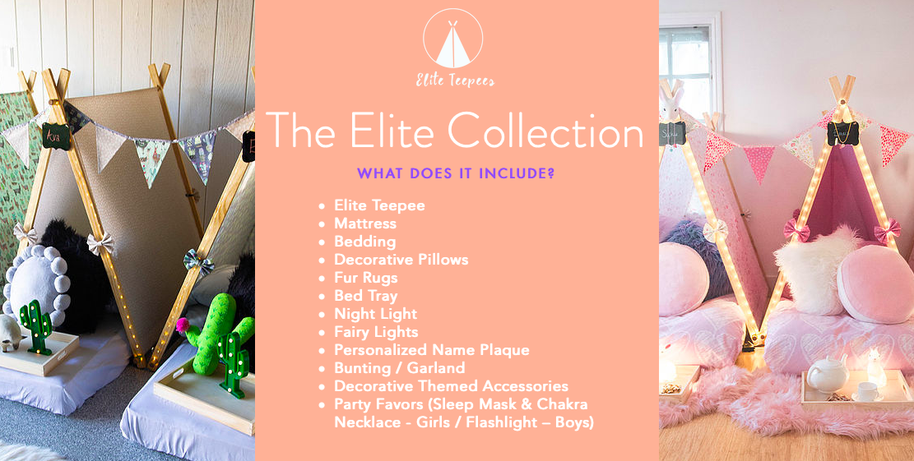
Everything for the sleepover is included... from handcrafted teepees, bed linen, lighting, decorative accessories, party favors and a sprinkling of magic! All the guests need to bring is their overnight kit and a sense of adventure!
- Quality of Collection Designs

This is where you come in! As the business owner, use your imagination and creative flair to produce exquisite collections for your client community.

- Quality of Product

Consumers are seeking unique and original experiences. The majority of Elite TeepeesSM products are hand crafted, using exclusive designs and quality materials.

- Teepee frames are handcrafted to Elite TeepeesSM’ exclusive design. With a high quality finish, the frames incorporate unique safety features.
- Decorative Teepee covers are handcrafted to Elite TeepeesSM’ exclusive design. Themed fabrics, with matching decorative bows and bunting complete the look.
- Deluxe mattresses are “proper camp mattresses’ (not blow up mattresses) and are full length, so suitable for adults too.
- Bed linen is sourced from Europe to provide a better fit and luxurious night’s sleep (European single sizes are narrower than a U.S. twin and therefore better suited to camp bed mattresses).
- Luxurious decorative pillows:- the majority of these are handcrafted.
- Accessories e.g. Fur Rugs, Bed Trays, Nightlights, Fairy Lights etc. are carefully sourced to provide an exquisite experience.

- Giving Back
At Elite TeepeesSM, we value the important things in life: family, friends, our community, and education. As the business owner, your passions and community will help you decide who or which causes to support. Here in San Diego, Elite TeepeesSM offers its services free of charge as auction initiatives, to help children’s education facilities raise funds.

How children Benefit from an Elite TeepeesSM Sleepover

Kids get to make and strengthen relationships. Most of us fondly remember sleepovers. There’s something about being in a relaxed home environment and the excitement of a night-time with friends, where we make friendships, create bonds and memories that last a lifetime.

Learning to adapt. Experiencing different household rules, cultures, foods, family constructs, conversations, attitudes etc. are all part of a kid’s learning. Sleepovers give kids the opportunity to learn that social boundaries can be different, which is great practice for the real world.
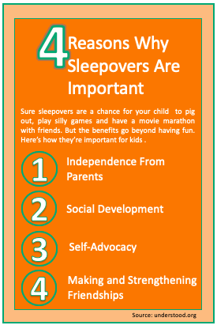
Build independence, confidence, and self-esteem. Time away from parents provides an excellent opportunity for kids to take initiative, exercise their autonomy and develop and social skills, which often builds self-esteem.

Help to build compassion, empathy, and understanding. Humans learn about feelings though face-to-face communication. Research shows that social skills could be as important as intelligence when it comes to achieving success.

Encourages fun and laughter. Everyone needs downtime and fun. A sleepover with friends offers just that!
How Parents Benefits from an Elite TeepeesSM Sleepover

Peace of mind. In today’s world where threats to everyone’s lives seems to be on the increase, where better can you keep your kids safe, other than in your own home?

Satisfaction. All parents desire to see their kids happy. Listening to kids chat and giggle is one of the greatest pleasures of being a parent. Knowing that they are providing a great unique experience for their kids, makes it extra special.

Hassle-free. An Elite TeepeesSM experience is hassle-free for the party thrower & party goers.

Time saving and convenient. Organizing sleepovers can cost precious time in today’s non-stop society, and the stress of planning it yourself often ends up outweighing the joy. Elite TeepeesSM enables parents time to relax and focus on their kids and their guests.

Enhances social identity. All Elite TeepeesSM experiences are social media worthy. As the first generation to come of age in the world of social media, there’s no doubt that millennials, who currently make up 90% of all new parents, are extremely identity conscious.

THE COMPANY AND ITS MANAGEMENT

Nikki Kay, Founder. Prior to starting her own business, Nikki enjoyed an exceptional career in Human Resources and Talent Acquisition consulting.
During her early career she worked in London for Gap (UK) as their Manager, Talent Acquisition, before relocating to her husband’s home-town of Wellington, New Zealand. There she worked for KPMG Consulting, prior to joining Futurestep, A Korn Ferry Company, in 2002. Over the next 16 years, Nikki held a number of leadership roles across New Zealand and Australia, Singapore, and U.S.A. The pinnacle of her career occurred in 2016 when, as the GM&VP Service Delivery, her team was recognized by the leading industry authority as the No. 1 service provider in North America.
The Elite TeepeesSM dream began long ago when Nikki, then an avid teen dancer, spent her free time designing and creating outfits for her performing dance troupe. Fast forward to 2018 when Nikki found herself in the enviable position of realizing her dream of building her own company. Inspiration struck when she arrived in Carlsbad. The stunningly beautiful environment and tranquil vibe revived childhood memories of the simple joys in life. One such joy were sleepovers; the essence of childhood, where friendships grow, and life-long memories are created.
Elite TeepeesSM was born from Nikki’s experience in business, her passion for creativity, a strong desire to create a business for others to be able replicate, and the motivation to bring something fun and exciting to the community.

Kelli Smith, CEO. Kelli bought Elite Teepees in April 2023 from the Founder, Nikki Kay. Kelli is a SuperMom in her own right – she has 3 gorgeous girls.Kelli brings a background in Occupational Therepy and childen’s education. Kelli loves to throw a great party, with all the creativety that goes into msking them feel special. Raised in Long Beach, Kelli epitomizes everything that is fabikius about Southern California: warm and friendly wirh a passion for living life to its fullest!!

mission and vision
“Making Dreams Come True” is Elite TeepeesSM mission. Elite TeepeesSM creates the magic – you create the memories.
Nikki’s vision for Elite TeepeesSM has always been to set the standard for exquisite curated sleepovers and to create a roadmap for others to follow. “To enable others to become the best version of themselves.”
Nikki has long held a passion for creativity , empowering others and sharing information. She believes that the key to success in this lucrative industry is having a clear understanding of your market and to differentiate service offerings based on the needs of your community. Nikki is keen for others to be empowered and reap the benefits of business ownership without the big-brother dictates of a franchisor.

BIRTHDAY PARTY INDUSTRY

- The Birthday Party industry had grown by 2018 to a $38 billion dollar industry. The children’s birthday party industry alone is worth $25 billion and growing.

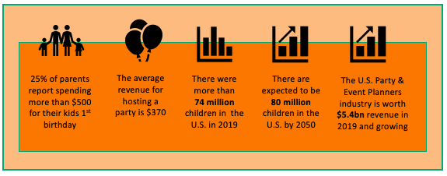

- Born between 1981 and 1994, more than 1 million millennial women become new mothers each year in the U.S.
  - In 2017 millennials made up 90% of all new parents. Millennials:
    - Overwhelmingly put their kids first. They value “raising successful children” much more highly than “living up to my full potential”
    - Value being a good parent over having a lasting marriage
    - Value experiences over belongings

- There's no shortage of potential customers in this industry. According to the Federal Interagency Forum on Child and Family Statistics, more than 73 million children under age 18 live in America, and this number is growing every year. By 2050, the number of children is projected to reach 80 million.

Kids' Party Planning is a booming industry. Coming-of-age parties are increasingly popular. In addition to the traditional birthday and graduation events, bar and bat mitzvahs, quinceañera; double-digit 10, teen 13, and sweet 16 parties, signal a trend toward increased celebration of kids' milestones.

Celebrities are inspiring others to set the bar high. As celebrities such as Jessica Simpson throw “Moana”-inspired birthday bashes with demigod Maui impersonators, or “30 Rock” star Tracy Morgan books a floor of Dylan’s Candy Bar, complete with “Despicable Me” Minions, for his 4-year-old daughter, the pressure is on to turn every birthday into a milestone event.

Spending is rising. In 2017, a Facebook survey reveals 15% of moms spend over $1000 on birthday parties. A survey by U.K. supermarket retailer Asda reported that the average British parent drops a whopping $28,000 on their kids’ birthdays through age 21.

LICENSEE BENEFITS

INCOME POTENTIAL

Full-time revenue: An executive income is absolutely achievable depending on the number of party experiences you hold and the number of kids who attend.

Part-time revenue: The majority of birthday parties are held on a Friday or Saturday evening, so weekend hours will be your primary work hours – perfect for anyone seeking an additional source of income.

Add-on revenue stream: This is also an incredible opportunity for a related business wanting to add additional services e.g. childcare center, children’s boutique, event planner, caterer, entertainer, tutor, photographer.

Elite TeepeesSM is primarily focused on Children’s birthday parties, however there is enormous potential to expand the service offering and generate income from multiple sources, e.g.
  - Extending services to any of life’s celebrations, for any age group, including:
    - Family Night
    - Bar / Bat Mitzvah,
    - Quinceañera
    - End of school year celebration
    - Team Bonding
    - Visiting family or friends
    - ‘Semi-sleepovers’ for those too young to spend an entire night

- Including a wider range of ‘Add-ons’ to offer for sale or overnight rental

- Partnering with related companies e.g. event planner, party balloon supplier, party supply store, entertainer, bakery, spa services, caterer/chef, florist, photographer.

- Introducing new product designs e.g. Teepees for more than one person, outdoor / sunshade teepees

Estimated Income based on 2 to 6 parties per week: $26k - $225k per annum:

Option | A | B | C
Price per overnight Teepee rental | $50 | $80 | $100
*Standard Delivery Fee | $50 | $70 | $120
** Revenue per experience  Assuming an average of 4 guests/party | $250 | $390 | $520
Annual Revenue - 2 parties per week | $26,000 | $40,560 | $54,080
Annual Revenue - 3 parties per week | $39,000 | $60,840 | $81,120
Annual Revenue - 4 parties per week | $52,000 | $81,120 | $108,160
Annual Revenue - 5 parties per week | $65,000 | $101,400 | $135,200
Annual Revenue - 6 parties per week | $78,000 | $121,680 | $162,240
** Revenue per experience  Assuming an average of 6 guests/party | $350 | $550 | $720
Annual Revenue - 2 parties per week | $36,400 | $57,200 | $74,880
Annual Revenue - 3 parties per week | $54,600 | $85,800 | $112,320
Annual Revenue - 4 parties per week | $72,800 | $114,400 | $149,760
Annual Revenue - 5 parties per week | $91,000 | $143,000 | $187,200
Annual Revenue - 6 parties per week | $109,200 | $171,600 | $224,640

Assumptions
Annual revenue based on 52 weeks
* Additional revenue from delivery outside core delivery zone, excluded
** Additional revenue from optional Add-ons, excluded
Option B is the current pricing structure for Elite TeepeesSM in Carlsbad, San Diego.
Pricing options are guidelines only. Business owners set their own prices, based on their knowledge of their market

To further clarify, Option B is the pricing used for Elite TeepeesSM, in Carlsbad, San Diego:
- The revenue per party, assuming an average of 4 sleepover guests/experience (i.e. 4 teepees) is made up of 4 x price per teepee @ $80 = $320, plus a standard delivery fee of $70. So the total revenue per experience is $390.
- For 2 parties per week i.e. 2 experiences each with 4 guests , the revenue per week would be 2 x the revenue per party @ $390 = $780. The annual revenue would be the weekly revenue @ $780 x 52 weeks = $40, 560
- For 6 parties per week, i.e. 6 parties each with 4 guests, the revenue per week would be 6 x $390 = $2,340. The annual revenue would be $2,340 x 52 weeks = $121,680
The same logic applies to an average of 6 guests per party: 2 parties per week would generate $57, 200 , and 6 parties per week would generate $171, 600, in annual revenue.

Hot Timing

NOW is the time to capitalize on this burgeoning industry. Millennial parents overwhelmingly put their kids first and are expected to continue to increase their spending on their kid’s parties. As the population of children continues to grow the industry continues to accelerate.

Massive growth in the curated sleepover market internationally has demonstrated parents continue to focus on celebrating life’s biggest moments. Although this type of luxury sleepover party in new to the U.S., it is expected to grow rapidly.

Unique Licensing Opportunity To Own Your Own Business

Elite TeepeesSM is the only company offering a licensing opportunity to join this on-trend, innovative, high growth market and become a part of the sleepover revolution that is taking the world by storm.

Few businesses are truly portable – if you move then you simply take the Elite TeepeesSM business with you and set up within your new community, so this business is very well suited to those who have to move, perhaps due to their spouses’ work commitments.

Owners receive a comprehensive Quick Start Guide to help them set up their own Elite TeepeesSM business, based on the founders experience, and use this knowledge to maximize profits and save precious time and money. Owners pay NO ROYALTIES, NO MARKETING FEES, AND NO FRANCHISE FEES.

Low Start-Up and Monthly Overhead

One of the best things about Elite TeepeesSM is that the initial investment is low compared to other businesses and your profit potential is greater because of low overhead.

- Home- based. No renting or buying office space
- No work commute . Save time and money.
- Tax advantages of having your home and office under one roof. You can deduct a part of your home’s operating and depreciation expenses as business expenses.
- Low start-up cost. It is estimated that an initial investment of $6500 - $7500 is required for the recommended 3 collections to kick-start your business. In many parts of the country you should be able to cover the costs of opening a business e.g. website development, marketing materials, legal fees, state incorporation fees, city business license fees etc. for around $2500, keeping your initial investment required under $10k. The cost may be a couple of thousand dollars more in coastal areas.
- Monthly costs are low, consisting mainly of staffing up as you become busy and/or expand, gas for deliveries, and laundry detergent for the bedding.

Flexible Hours and Time

The beauty of an Elite TeepeesSM business is that weekend hours are your primary work hours as most parties are held on Saturdays. You can choose if you also want to deliver services on Fridays (also popular for birthdays) or any other days of the week to suit your schedule, and still have time for friends and family. .

Job Satisfaction

If you love working with kids, being creative, having flexible hours, are highly organized and committed to service excellence, this could very well be your dream job! Bringing pure joy into people’s lives is unbelievably rewarding. The reaction of kids when they first see their Elite TeepeesSM is priceless, and their squeals of delight is nothing short of magical.

An Elite TeepeesSM business lends itself very well to working alongside an associate for the party deliveries and set-ups. The associate will likely be a low cost resource e.g. a local student, family member or friend.

ELITE TEEPEESSM LICENSING SUMMARY

The Elite TeepeesSM Quick Start Guide will provide you with the knowledge and tools you need to get started right away by following the path the founder used to create her business.

Educational Investment & One-Time Licensing Fee: $995
Annual License Renewal Fee: $600

The Elite TeepeesSM Quick Start Guide includes:

- How To Set Your Business Up For Success
  - Client Administration Templates
- How To Plan Your Workspace
- Marketing, PR And Promotional Techniques , including the Elite TeepeesSM Logo
- Vendor List
- Handcrafted Teepees: “How To Make” Guides:
  - Teepee Frames
  - Teepee Covers, Bows and Backstraps
  - Bunting
  - Teepee Carrier
- Client Deliveries
  - Scheduling Guidelines
  - How to Create the Elite TeepeesSM Experience
- Ideas for Additional Revenue Streams
Bonus Items
- Sleepover Game: Truth or Dare
- Marketing Collateral, including: Brand Manual, Elite TeepeesSM Flyers, Theme Board, Newsletter, Magazine Article

Estimated Start-Up investment:
- $6500 - $7500 to create 3 complete Elite TeepeesSM collections
- $2500+ estimated costs to open a business in your geographical area, including website development, marketing materials, legal fees, state incorporation fees, city business license fees etc.

